**Assignment 2**

**Group: DWDM19G04**

**Roll Numbers: 2016BTECS00063, 2016BTECS00081, 2016BTECS00103**

**Batch: B7**

**Date: 31st August, 2019**

**Title: Data Warehousing for Customer Order Processing**

**Problem Statement:**

To design and implement a data warehouse for a customer order processing system in a company using Oracle 11g.

**Theory:**

Data Warehousing: A data warehousing is defined as a technique for collecting and managing data from varied sources to provide meaningful business insights. It is a blend of technologies and components which aids the strategic use of data.

Types of Data Warehouses are:

1. Enterprise Data Warehouse:

Enterprise Data Warehouse is a centralized warehouse. It provides decision support service across the enterprise. It offers a unified approach for organizing and representing data. It also provide the ability to classify data according to the subject and give access according to those divisions.

1. Operational Data Store:

Operational Data Store, which is also called ODS, are nothing but data store required when neither Data warehouse nor OLTP systems support organizations reporting needs. In ODS, Data warehouse is refreshed in real time. Hence, it is widely preferred for routine activities like storing records of the Employees.

1. Data Mart:

A data mart is a subset of the data warehouse. It specially designed for a particular line of business, such as sales, finance, sales or finance. In an independent data mart, data can collect directly from sources.

**Output:**

**Headquarter Database:**

CREATE TABLE CUSTOMERDW(

CUSTOMER_ID INTEGER PRIMARY KEY,

CUSTOMER_NAME VARCHAR(20),

CITY_ID INTEGER,

FIRST_ORDER_DATE DATE

);

INSERT INTO CUSTOMERDW VALUES(1001,'RITIK',10,'3-FEB-2014');

INSERT INTO CUSTOMERDW VALUES(1002,'ABHINAV',20,'21-AUG-2011');

INSERT INTO CUSTOMERDW VALUES(1003,'HIMANSHU',11,'27-JUN-2018');

INSERT INTO CUSTOMERDW VALUES(1004,'SHAILESH',20,'26-DEC-2001');

INSERT INTO CUSTOMERDW VALUES(1005,'ANKUR',14,'16-DEC-2017');

INSERT INTO CUSTOMERDW VALUES(1006,'AJAY',24,'11-NOV-2012');

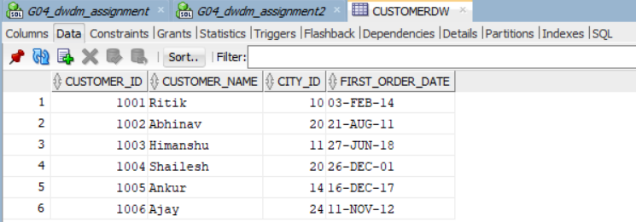

CREATE TABLE WALKIN_CUSTOMERS(

CUSTOMER_ID INTEGER,

TOURISM_GUIDE INTEGER,

WALKIN_TIME TIMESTAMP,

FOREIGN KEY(CUSTOMER_ID) REFERENCES CUSTOMERDW(CUSTOMER_ID)

);

INSERT INTO WALKIN_CUSTOMERS VALUES(1001,01,'1-JUN-2017');

INSERT INTO WALKIN_CUSTOMERS VALUES(1001,11,'6-JUL-2018');

INSERT INTO WALKIN_CUSTOMERS VALUES(1002,02,'18-FEB-2011');

INSERT INTO WALKIN_CUSTOMERS VALUES(1004,01,'23-NOV-2019');

INSERT INTO WALKIN_CUSTOMERS VALUES(1003,03,'9-DEC-2006');

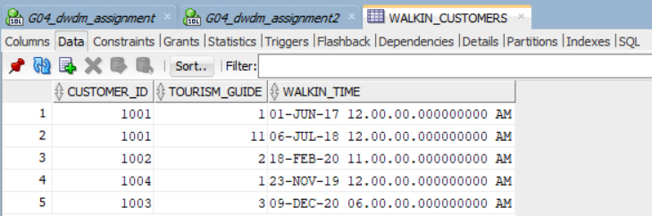

CREATE TABLE MAIL_ORDER_CUSTOMERS(

CUSTOMER_ID INTEGER,

POST_ADDRESS VARCHAR(20),

MAIL_ORDER_TIME TIMESTAMP,

FOREIGN KEY(CUSTOMER_ID) REFERENCES CUSTOMERDW(CUSTOMER_ID)

);

INSERT INTO MAIL_ORDER_CUSTOMERS VALUES(1002,'SANGLI','12-FEB-2015');

INSERT INTO MAIL_ORDER_CUSTOMERS VALUES(1001,'PUNE','10-DEC-2012');

INSERT INTO MAIL_ORDER_CUSTOMERS VALUES(1004,'KOLHAPUR','12-JAN-2006');

INSERT INTO MAIL_ORDER_CUSTOMERS VALUES(1003,'NAGPUR','4-NOV-2018');

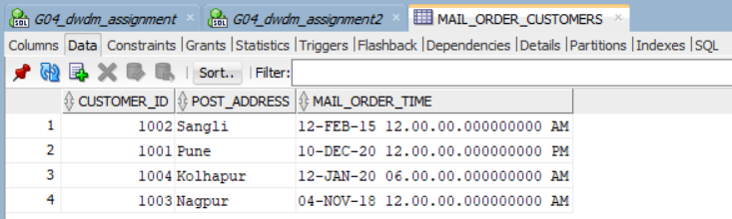

SALES DATABASE

CREATE TABLE HEADQARTERS(

CITY_ID INTEGER PRIMARY KEY,

CITY_NAME VARCHAR(20),

HEADQUARTER_ADDR VARCHAR(20),

STATE VARCHAR(20),

HEADQARTERS_TIME TIMESTAMP

);

INSERT INTO HEADQARTERS VALUES(100,'SANGLI','M.G.NAGAR','MAHARASHTRA','29-JUL-2001');

INSERT INTO HEADQARTERS VALUES(101,'PUNE','SP ROAD','MAHARASHTRA','12-MAR-2002');

INSERT INTO HEADQARTERS VALUES(102,'KOLHAPUR','VISHRAMBAGH','MAHARASHTRA','20-DEC-2003');

INSERT INTO HEADQARTERS VALUES(20,'NAGPUR','MS CORNER','MAHARASHTRA','10-APR-2001');

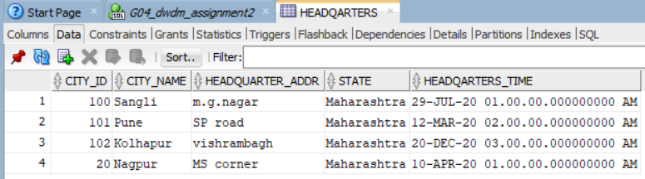

CREATE TABLE STORES(

STORE_ID INTEGER PRIMARY KEY,

CITY_ID INTEGER,

PHONE INTEGER,

STORES_TIME TIMESTAMP,

FOREIGN KEY (CITY_ID) REFERENCES HEADQARTERS(CITY_ID)

);

INSERT INTO STORES VALUES(9000,102,9172162833,'11-JUL-2008');

INSERT INTO STORES VALUES(9001,101,8830448411,'22-MAY-2007');

INSERT INTO STORES VALUES(9002,100,9423825515,'14-JAN-2006');

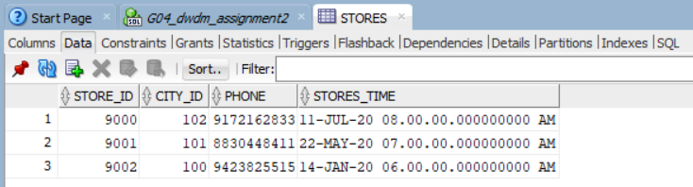

CREATE TABLE ITEMS_2(

ITEM_ID INTEGER PRIMARY KEY,

DESCRIPTION VARCHAR(20),

ITEM_SIZE INTEGER,

WEIGHT REAL,

UNIT_PRICE REAL,

ITEMS_TIME TIMESTAMP

);

INSERT INTO ITEMS_2 VALUES(1,'MOUSE',10*40,10,900,'23-JUL-2010');

INSERT INTO ITEMS_2 VALUES(2,'BOOKS',10*10,12,499,'7-DEC-2008');

INSERT INTO ITEMS_2 VALUES(3,'BOTTLE',5*50,4,50,'28-MAY-2009');

INSERT INTO ITEMS_2 VALUES(4,'MOBILE',5*5,18,40000,'4-APR-2011');

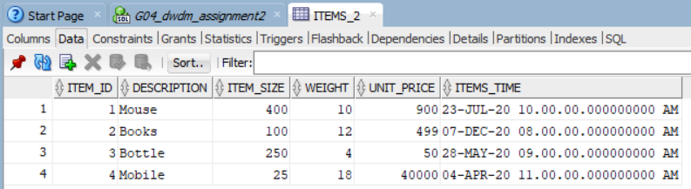

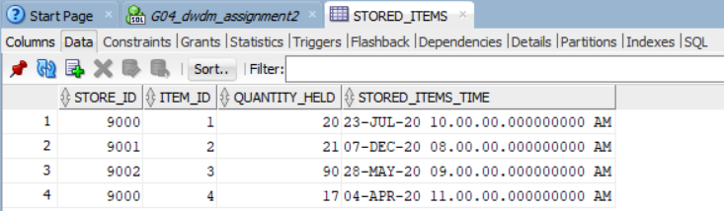

CREATE TABLE STORED_ITEMS(

STORE_ID INTEGER,

ITEM_ID INTEGER,

QUANTITY_HELD INTEGER,

STORED_ITEMS_TIME TIMESTAMP,

PRIMARY KEY(STORE_ID,ITEM_ID),

FOREIGN KEY (STORE_ID) REFERENCES STORES(STORE_ID),

FOREIGN KEY (ITEM_ID) REFERENCES ITEMS_2(ITEM_ID)

);

INSERT INTO STORED_ITEMS VALUES(9000,1,20,'23-JUL-2010');

INSERT INTO STORED_ITEMS VALUES(9001,2,21,'7-DEC-2008');

INSERT INTO STORED_ITEMS VALUES(9002,3,90,'28-MAY-2009');

INSERT INTO STORED_ITEMS VALUES(9000,4,17,'4-APR-2011');

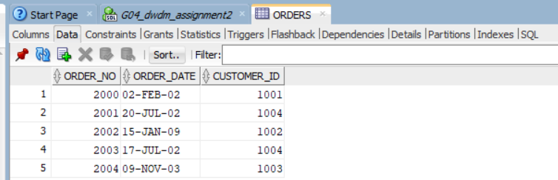

CREATE TABLE ORDERS(

ORDER_NO INTEGER PRIMARY KEY,

ORDER_DATE DATE,

CUSTOMER_ID INTEGER

);

INSERT INTO ORDERS VALUES(2000,'2-FEB-2002',1001);

INSERT INTO ORDERS VALUES(2001,'20-JUL-2002',1004);

INSERT INTO ORDERS VALUES(2002,'15-JAN-2009',1002);

INSERT INTO ORDERS VALUES(2003,'17-JUL-2002',1004);

INSERT INTO ORDERS VALUES(2004,'9-NOV-2003',1003);

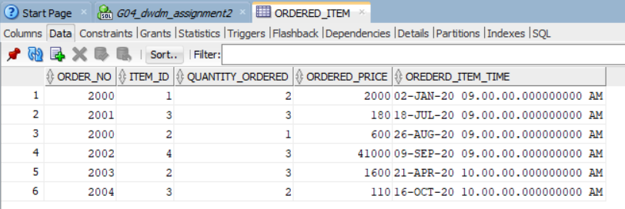

CREATE TABLE ORDERED_ITEM(

ORDER_NO INTEGER,

ITEM_ID INTEGER,

QUANTITY_ORDERED INTEGER,

ORDERED_PRICE REAL,

OREDERD_ITEM_TIME TIMESTAMP,

PRIMARY KEY(ORDER_NO,ITEM_ID),

FOREIGN KEY (ORDER_NO) REFERENCES ORDERS(ORDER_NO),

FOREIGN KEY (ITEM_ID) REFERENCES ITEMS_2(ITEM_ID)

);

INSERT INTO ORDERED_ITEM VALUES(2000,1,2,2000,'2-JAN-2009');

INSERT INTO ORDERED_ITEM VALUES(2001,3,3,180,'18-JUL-2009');

INSERT INTO ORDERED_ITEM VALUES(2000,2,1,600,'26-AUG-2009');

INSERT INTO ORDERED_ITEM VALUES(2002,4,3,41000,'9-SEP-2009');

INSERT INTO ORDERED_ITEM VALUES(2003,2,3,1600,'21-APR-2010');

INSERT INTO ORDERED_ITEM VALUES(2004,3,2,110,'16-OCT-2010');

1. Find all the stores along with city, state, phone, description, size, weight and

unit price that hold a particular item of stock.

SELECT H.CITY_NAME,STATE,PHONE,DESCRIPTION,ITEM_SIZE,WEIGHT,UNIT_PRICE

FROM STORED_ITEMS,ITEMS_2,HEADQARTERS H ,STORES S

WHERE STORED_ITEMS.ITEM_ID=ITEMS_2.ITEM_ID AND S.CITY_ID= H.CITY_ID AND STORED_ITEMS.STORE_ID= S.STORE_ID;

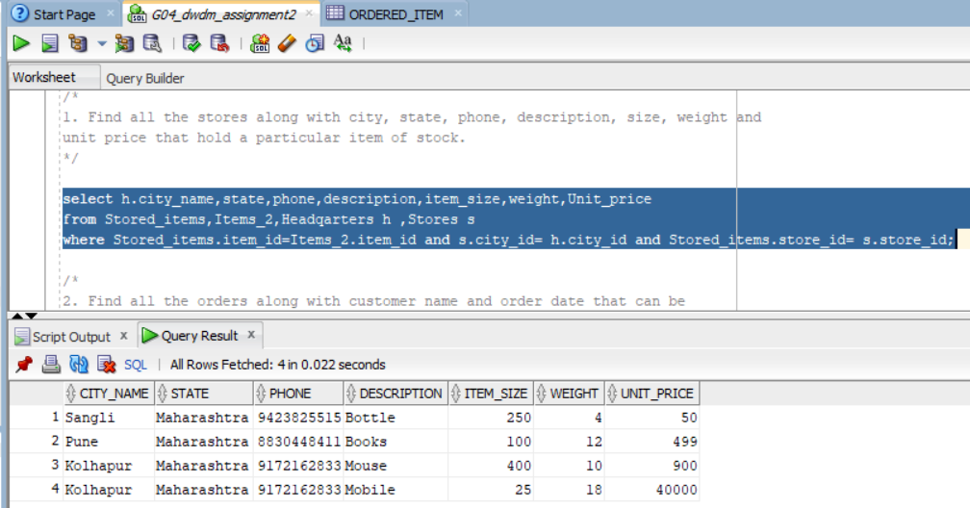

2. Find all the orders along with customer name and order date that can be

fulfilled by a given store.

SELECT UNIQUE CUSTOMER_NAME,ORDER_DATE

FROM CUSTOMERDW, ORDERS,STORES ,ORDERED_ITEM O, STORED_ITEMS S

WHERE ORDERS.ORDER_NO=O.ORDER_NO AND S.STORE_ID=STORES.STORE_ID AND CUSTOMERDW.CUSTOMER_ID=ORDERS.CUSTOMER_ID AND S.QUANTITY_HELD>O.QUANTITY_ORDERED;

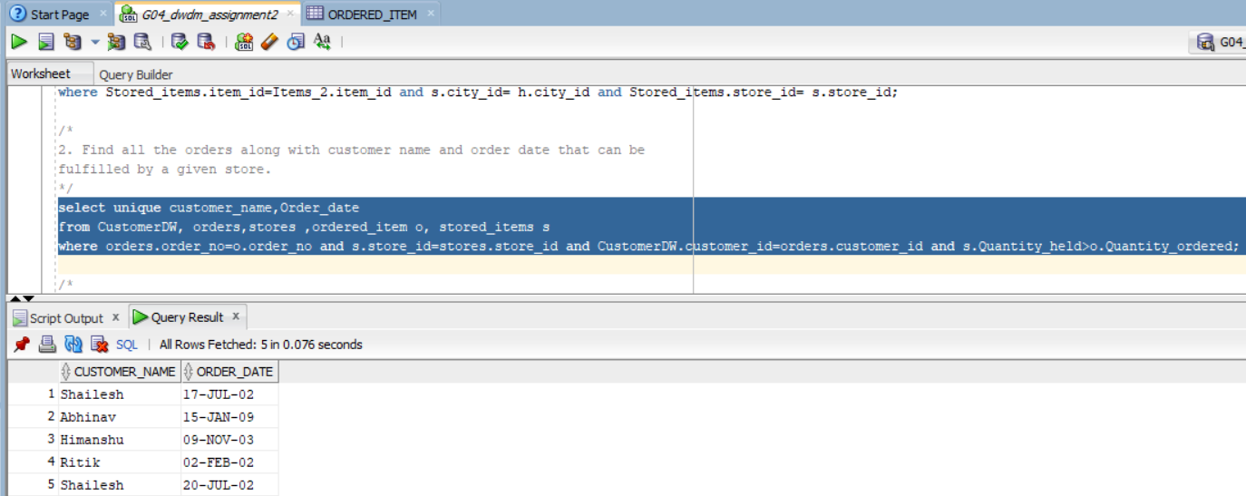

3. Find all stores along with city name and phone that hold items ordered by

given customer.

SELECT STORES.STORE_ID,CITY_NAME,PHONE

FROM STORES,HEADQARTERS H,ORDERS,ORDERED_ITEM O, STORED_ITEMS S

WHERE ORDERS.ORDER_NO=O.ORDER_NO AND S.STORE_ID=STORES.STORE_ID AND O.ITEM_ID=S.ITEM_ID AND H.CITY_ID= STORES.CITY_ID;

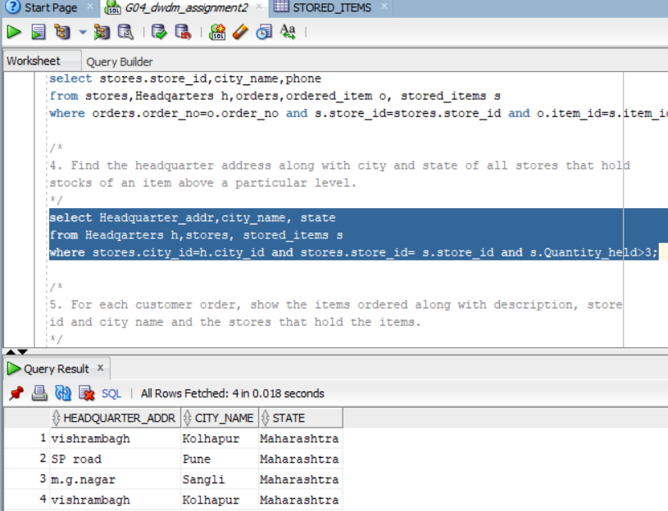

4. Find the headquarter address along with city and state of all stores that hold

stocks of an item above a particular level.

SELECT HEADQUARTER_ADDR,CITY_NAME, STATE

FROM HEADQARTERS H,STORES, STORED_ITEMS S

WHERE STORES.CITY_ID=H.CITY_ID AND STORES.STORE_ID= S.STORE_ID AND S.QUANTITY_HELD>3;

5. For each customer order, show the items ordered along with description, store

id and city name and the stores that hold the items.

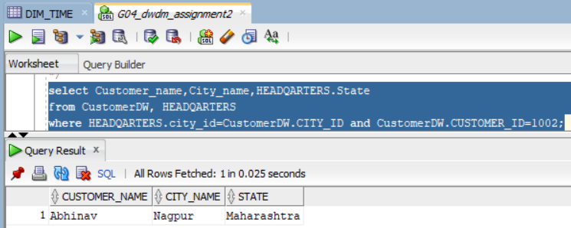

SELECT UNIQUE O.ITEM_ID,DESCRIPTION,S.STORE_ID,CITY_NAME

FROM ITEMS_2,STORES,STORED_ITEMS S,ORDERS,ORDERED_ITEM O,HEADQARTERS H,CUSTOMERDW

WHERE H.CITY_ID=STORES.CITY_ID

AND ITEMS_2.ITEM_ID=O.ITEM_ID

AND O.ITEM_ID=S.ITEM_ID AND STORES.STORE_ID= S.STORE_ID;

6. Find the city and the state in which a given customer lives.

SELECT CUSTOMER_NAME,CITY_NAME,HEADQARTERS.STATE

FROM CUSTOMERDW, HEADQARTERS

WHERE HEADQARTERS.CITY_ID=CUSTOMERDW.CITY_ID AND CUSTOMERDW.CUSTOMER_ID=1002;

7. Find the stock level of a particular item in all stores in a particular city.

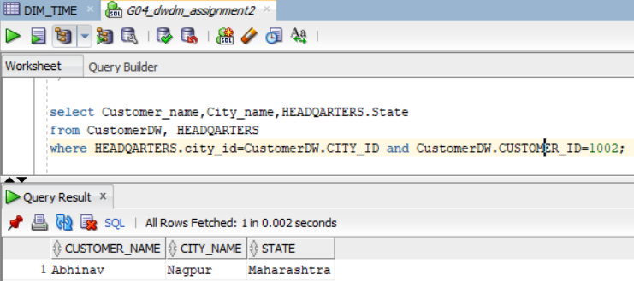

SELECT CUSTOMER_NAME,CITY_NAME,HEADQARTERS.STATE

FROM CUSTOMERDW, HEADQARTERS

WHERE HEADQARTERS.CITY_ID=CUSTOMERDW.CITY_ID AND CUSTOMERDW.CUSTOMER_ID=1002;

8. Find the items, quantity ordered, customer, store and city of an order.

SELECT UNIQUE CUSTOMER_NAME,CITY_ID,QUANTITY_ORDERED,DESCRIPTION,S.STORE_ID

FROM ORDERS,CUSTOMERDW,ORDERED_ITEM,ITEMS_2, STORED_ITEMS S

WHERE ORDERS.ORDER_NO = ORDERED_ITEM.ORDER_NO AND

CUSTOMERDW.CUSTOMER_ID=ORDERS.CUSTOMER_ID AND ORDERED_ITEM.ITEM_ID= ITEMS_2.ITEM_ID AND S.ITEM_ID= ITEMS_2.ITEM_ID;

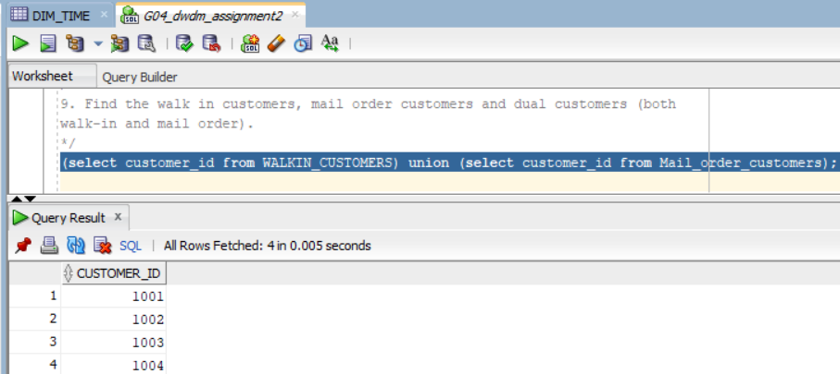

9. Find the walk in customers, mail order customers and dual customers (both

walk-in and mail order).

(SELECT CUSTOMER_ID FROM WALKIN_CUSTOMERS) UNION (SELECT CUSTOMER_ID FROM MAIL_ORDER_CUSTOMERS);

**Conclusion**:

We implemented multiple databases for an OLTP scenario and ran various queries over the entire system.